 | HOLY CROSS COLLEGE  SEMESTER 1, 2019  Question/Answer Booklet

Please place your student identification label in this box
11 PHYSICS

Student Name ___________________________________

Student’s Teacher __________________________________________

Time allowed for this paper
Reading time before commencing work: 10 minutes
Working time for paper: 3 hours

Materials required/recommended for this paper

To be provided by the supervisor
This Question/Answer Booklet
Multiple-choice Answer Sheet
Data Sheet

To be provided by the candidate
Standard items: pens, pencils, eraser, correction fluid, ruler, highlighters
Special items: non-programmable calculators satisfying the conditions set by the School Curriculum and Standards Authority for this course

Important note to candidates
No other items may be taken into the examination room. It is your responsibility to ensure that you do not have any unauthorised notes or other items of a non-personal nature in the examination room. If you have any unauthorised material with you, hand it to the supervisor before reading any further.

Structure of this paper

Section | Number of questions available | Number of questions to be answered | Suggested working time  (minutes) | Marks available | Percentage of exam
Section One:  Short Answers | 15 | 15 | 60 | 67 | 38
Section Two:  Problem-solving | 6 | 6 | 90 | 92 | 52
Section Three:  Comprehension | 1 | 1 | 30 | 16 | 10
 |  |  |  | 175 | 100

Instructions to candidates

1. The rules for the conduct of examinations at Holy Cross College are detailed in the College Examination Policy. Sitting this examination implies that you agree to abide by these rules.

2. Write your answers in this Question/Answer Booklet.

3. Working or reasoning should be clearly shown when calculating or estimating answers.

4. You must be careful to confine your responses to the specific questions asked and to follow any instructions that are specific to a particular question.

5. Spare pages are included at the end of this booklet. They can be used for planning your
responses and/or as additional space if required to continue an answer.

• Planning: If you use the spare pages for planning, indicate this clearly at the top of the
page.
• Continuing an answer: If you need to use the space to continue an answer, indicate in
the original answer space where the answer is continued, i.e. give the page number.
Fill in the number of the question(s) that you are continuing to answer at the top of the
page.

6. Answers to questions involving calculations should be evaluated and given in decimal
form. It is suggested that you quote all answers to three significant figures, with the
exception of questions for which estimates are required. Despite an incorrect final result,
credit may be obtained for method and working, providing these are clearly and legibly set
out.

7. Questions containing the instruction "estimate" may give insufficient numerical data for their
solution. Students should provide appropriate figures to enable an approximate solution to
be obtained. Give final answers to a maximum of two significant figures and include appropriate units where applicable.

8. Note that when an answer is a vector quantity, it must be given with magnitude and direction.

9. In all calculations, units must be consistent throughout your working.
SECTION ONE: Short Answers

Marks Allotted: 67 marks out of 175 total.

Attempt ALL 15 questions in this section. Answers are to be written in the space below or next to each question.

1. The Cassini space probe (mass 5.50 x 10⁴ kg) was successfully launched onboard a TITAN IV rocket from Cape Canaveral on October 15 1997 on a voyage to Saturn. The diagram below shows the deployed space probe moving at a constant velocity of 8.90 x 10² ms⁻¹ towards A. To change course, a sideways force is produced by firing the thruster. This increases the velocity towards B from 0 to 60.0 ms⁻¹ in 25.0 s. Determine the resultant velocity after 25.0 s. [4 marks]
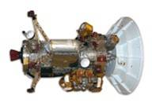
A
B
Thruster

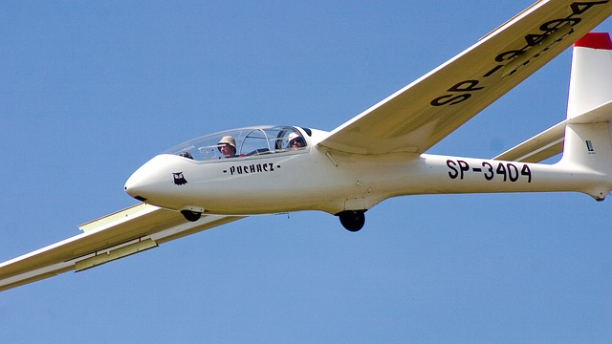
2. A glider, as shown on the right, is a light aircraft that is designed to fly without using an engine over open country. As the land is heated by the sun, it is able to operate more effectively. Explain the reasons for this, using Physics concepts.
[3 marks]

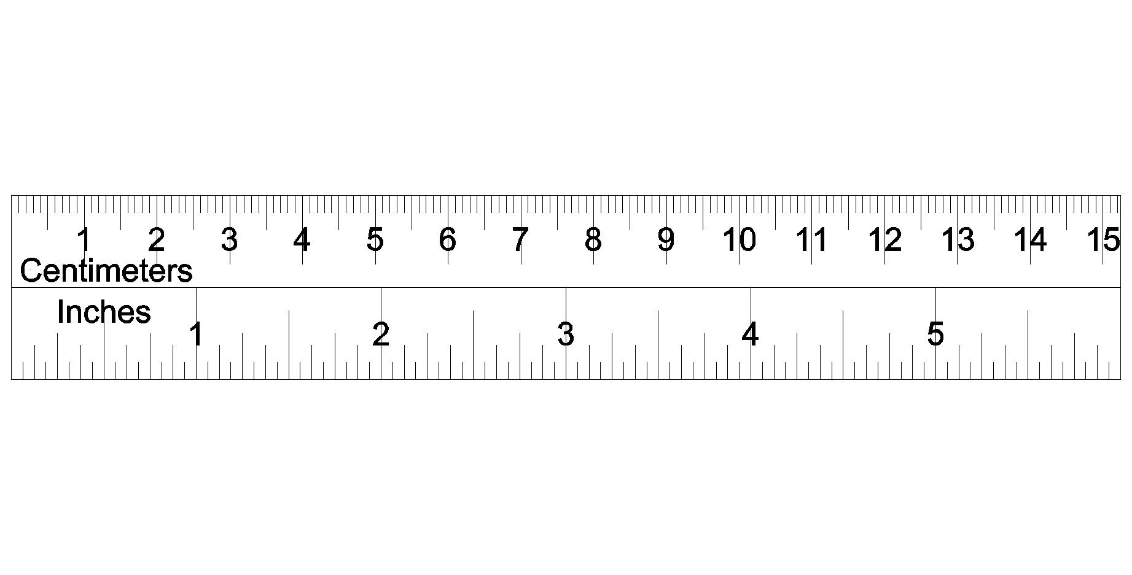
3. Aiden is measuring the following shaded perfect circle and he puts a ruler next to it, as shown on the right.

Write the absolute and relative uncertainties of the diameter of the circle below.

(a) Diameter with absolute uncertainty. [2 marks]

(b) Diameter with relative or percentage uncertainty. [2 marks]

4. The Thrust SSC car raised the world speed record in 1998. The mass of the car was
1.00 x 10⁴ kg. A 12.0 s run by the car may be considered in two stages of constant acceleration. Stage one was from 0 to 4.0 s and stage two from 4.0 to 12.0 s.

(a) In stage one, the car accelerates from rest to 44.0 ms⁻¹ in 4.0 s. Calculate the acceleration and the force required to provide this acceleration. [4 marks]

(b) In stage two it continued to accelerate until it reached a speed of 284 ms⁻¹ in a
further 8.0 s. Calculate the acceleration in stage two. [2 marks]

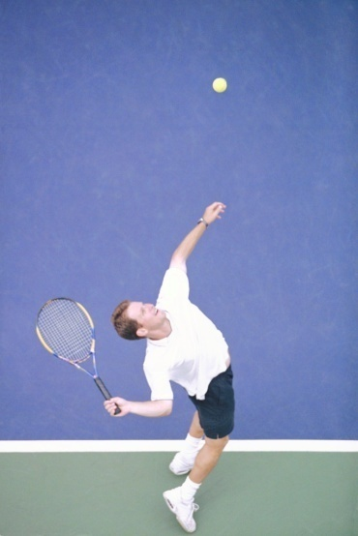
5. In the Hopman Cup in Perth in January, Matt Ebden served at full speed, hitting the ball at 225 kmh⁻¹ (assumed horizontal). The ball had a mass of 58.5 g and was in contact with the strings for 6.00 ms.

(a) Calculate the change in momentum of the tennis ball during his serve. [4 marks]

(b) Determine the impulsive force exerted by the racquet onto the ball. [3 marks]

6. Calculate how much energy needs to be removed from 0.500 kg of water at 24.0 °C to convert it into ice at -4.00 °C ice. [4 marks]

7. An Australian Rules football is travelling at 17.0 ms⁻¹ at a height of 20.0 m after being kicked by a player. If the mass of the ball is 455 g and assuming the ball is kicked very close to the ground, determine the work done by the player when kicking the ball. [4 marks]

8. A plane landing at Hong Kong airport has to contend with a strong wing of 80.0 kmh⁻¹ heading W25.0°S. If the plane, which is moving at 265 kmh⁻¹, is attempting to land on a runway that runs due north, calculate the heading that the plane must have so it lands safely on the runway. Include a labelled vector diagram to show this situation.
[4 marks]

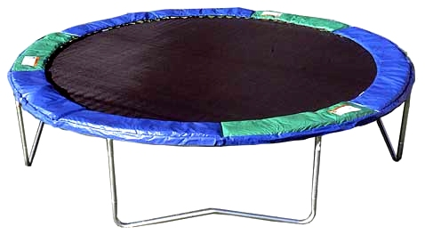
9. The diagram below shows a trampoline. Explain, in terms of momentum, why you do not hurt yourself when falling into the mat, but you would if you missed the mat and hit the ground?
[4 marks]

10. Your Physical Education teacher throws a cricket ball to you at a certain speed and you catch it. The teacher is now going to throw a medicine ball to you; its mass is ten times the mass of the cricket ball. You are given the following choices - you can have the medicine ball thrown with:

(a) the same speed as the cricket ball
(b) the same momentum
(c) the same kinetic energy

Rank these choices from 'easiest to catch' to 'hardest to catch. [3 marks]

11. The graph below represents the motion of a car of mass 1.40 x10³ kg travelling in a straight line.
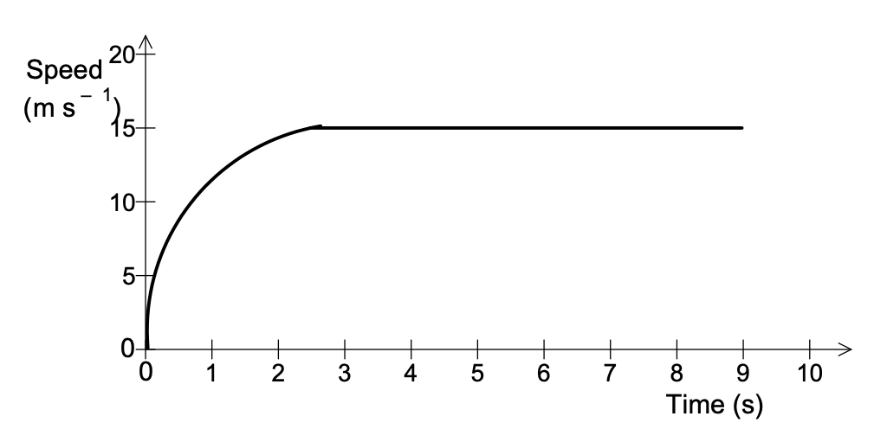

(a) Without calculations, describe how the resultant force acting on the car varies over the 10 s period. [2 marks]

(b) Estimate how far the car has travelled after 6.0 s. [3 marks]

12. In Kalgoorlie, an underground mine cage of mass 1.70 x 10³ kg is hauled vertically upwards. Near the surface, it decelerates at 2.30 ms⁻². Determine the tension in the supporting cable at this time. [3 marks]

13. An object of mass 2.00 kg moving at 16.0 ms⁻¹ north collides with a stationary object. The two objects coalesce (join) and move off together at 7.50 ms⁻¹ north.

(a) Calculate the mass of the unknown object. [4 marks]

(b) Is the collision elastic? Support your answer with a calculation. [3 marks]

14. A man loading goods onto a storage platform rolls a 215 kg barrel up a ramp, inclined at
23.0 ° to the horizontal, onto the platform that is 1.20 m off the ground. Calculate the force he must exert parallel to the ramp, assuming he just balances the force down the ramp due to gravity acting on the barrel. [3 marks]

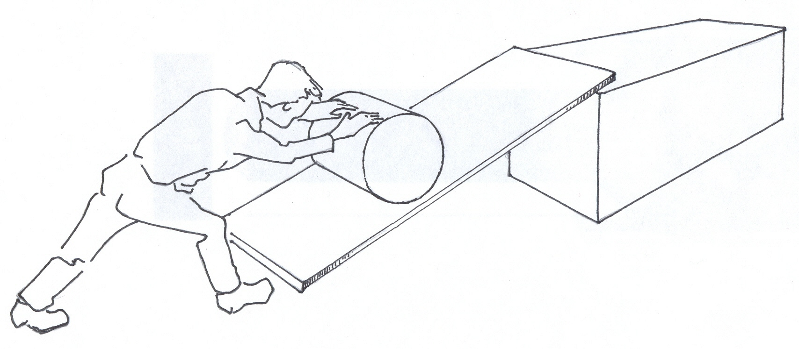

15. An electric water chiller containing 175 kg of water cools the water from 25.0°C to 15.0°C in 2.50 hours. Calculate

(a) the energy lost by the water as it cools to 15.0°C. [3 marks]

(b) the power output of the chiller in kilowatts (kW). [3 marks]

THIS PAGE HAS BEEN DELIBERATELY LEFT BLANK.

SECTION TWO: Problem Solving

Marks allotted: 92 marks out of 175 marks total.

Attempt ALL 6 questions in this section. The marks allocated to each question are given and the answers should be written in the spaces provided.

[20 marks]

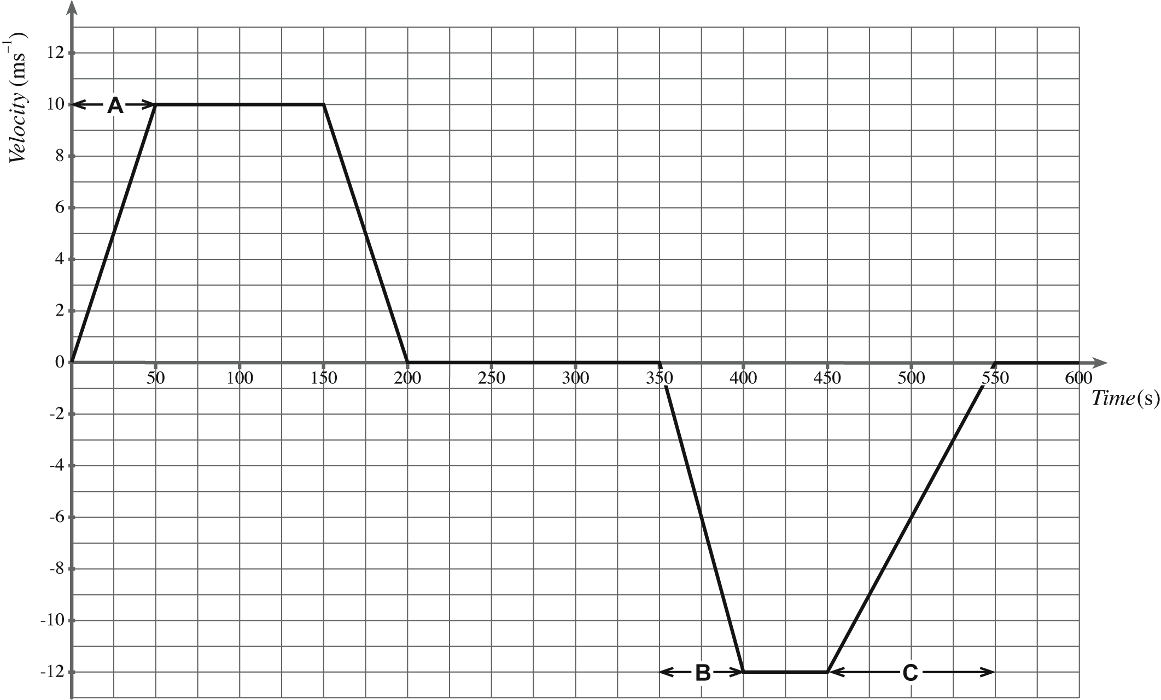
16. On a school ski trip, a mini-bus transports passengers between the car park and the ski centre. The bus starts from the car park and travels north to the ski centre, drops off the passengers and returns to the car park. The velocity-time graph for the bus journey is given below.
Time (s)
Velocity
(ms⁻¹)

(a) The time taken by the bus to travel from the car park to the ski centre is 200 seconds. From the graph, calculate the distance travelled by the bus from the car park to the ski centre. [3 marks]

(b) Draw an acceleration – time graph of this motion, giving clear scales on each axis. You may need to do some calculations. Use the space below at the bottom of the page. [7 marks]

(c) The mass of the bus is 2.25 x 10³ kg. The combined mass of the driver and the passengers is 8.00 x 10² kg. Calculate the force required to produce the acceleration calculated during section A of its journey. [2 marks]

After unloading the passengers at the ski centre, the bus now travels back to the car park with some tourists.
(d) Explain why the second part of the graph is drawn below the time axis. [1 mark]

(e) Describe the motion of the bus during section B of its journey. [2 marks]

(f) The unbalanced force acting on the bus during section C of its journey is 342N. Estimate the number of passengers in the bus. [5 marks]

[13 marks]
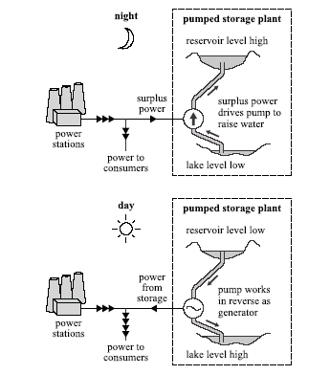
17. The diagram right shows the principle of a hydroelectric pumped storage plant.

During times when there is a low demand for electricity, the spare capacity of other power stations is used to pump water from the lake into the reservoir. The potential energy of the water is then converted into electricity when needed to satisfy peak demand.
For this plant, the water falls an average distance of 3.70 x 10² m between the reservoir and the generator. The mass of water stored in the reservoir when it is full is 1.00 x 10¹⁰ kg.

(a) Show that the useful gravitational potential energy stored when the reservoir is full is about 4.0 x 10¹³ J. [2 marks]
(b) Calculate the speed of the water as it reaches the generator, assuming that no energy is lost as the water falls. [4 marks]

(c) The pumped storage plant has four 1.00 x 10² MW generators. Calculate the longest time (in hours) for which the stored energy alone could provide power at maximum output. Assume that all the stored gravitational potential energy can be converted into electrical energy. [4 marks]

(d) In practice, not all the stored energy that is put into the system during the night can be retrieved as electrical energy during the day. State and explain how energy is lost in the system. [3 marks]

[18 marks]

18. A quality-control officer tests a strand of nylon cord by subjecting it to various loads (force) and recording the subsequent extensions or change in length. The diagram shows the experimental set-up.
load
Nylon cord
length

The original length of the nylon string is 100 mm, measured to the nearest millimetre.

Elastic materials (those that return to their original shape and dimensions) follow Hooke's Law, which is given by:

F = kΔx

where F = the force in the material (the load) (N)
k = the spring constant or stiffness of the material (Nm⁻¹)
Δx = extension or change in length (m)

(a) Complete the following: [2 marks]

Independent variable:

Dependent variable:

(b) Complete the table below. [2 marks]

F (N) | 0 | 10.0 | 20.0 | 30.0 | 40.0 | 50.0
L (mm) | 100 | 108 | 117 | 124 | 132 | 139
Δx (mm)

(c) Calculate the relative or percentage uncertainty for the length of the nylon string if the load is 20.0 N. [2 marks]

(d) Plot a graph using F (load) and Δx. [4 marks]

(e) Calculate the gradient of the line of best fit to find the value for k. [4 marks]

Note: A spare graph paper is at the back of the booklet if you need it.
(f) What does the gradient tell you about the string? [1 mark]

(g) Estimate the length of the nylon when 60.0 N of load is used. Show clear working.
[3 marks]

THIS PAGE HAS BEEN DELIBERATELY LEFT BLANK.

[15 marks]

19. Paul conducts an experiment in the Science laboratory in order to produce a heating curve. A quantity of crushed ice is removed from a freezer, dried with a paper towel and placed in a calorimeter. Thermal energy is supplied to the ice at a constant rate and it is continually stirred. The temperature of the contents of the calorimeter is recorded every 15 seconds.

The graph below shows the variation with time t of the temperature T of the contents of the calorimeter.
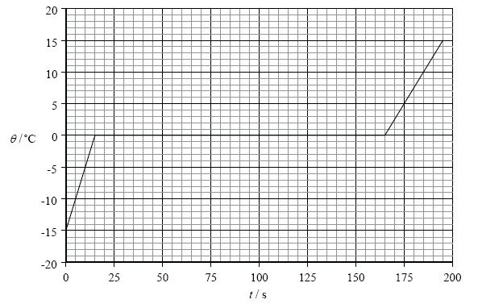
T ( ºC)
t (s)
(a) On the graph above, mark with an X the data point on the graph at which all the ice has just melted. [1 mark]

(b) Explain, with reference to the energy of the molecules, the constant temperature region of the graph. [4 marks]

(c) The mass of the ice that Paul used was 0.250 kg. Use this data and data from the graph to determine the power of the heater. [4 marks]

(d) From the data supplied, determine the specific heat capacity of ice. [4 marks]

(e) Why was the ice dried before it was placed in the calorimeter? [2 marks]
[15 marks]
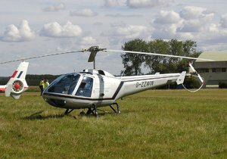
20. A helicopter such as the one shown at right has a mass of
5.00 tonnes and is sitting on the ground with its engines idling, producing a lift force of 1.60 x 10⁴ N.
(a) Calculate the normal reaction force of the ground on the helicopter while the engine is idling. [3 marks]

(b) The pilot now increases the speed and tilt of the rotors, so that the lift force becomes 6.00 x 10⁴ N. Calculate the upwards acceleration of the helicopter. [3 marks]

(c) If the helicopter continues to accelerate at this rate, how long will it take to reach a height of 3.50 x 10² m? (If you did not calculate an answer for (b), use 2.40 ms⁻².) [2 marks]

(d) What will be its velocity at 3.50 x 10² m altitude? [2 marks]

Just as the helicopter reaches the height of 3.50 x 10² m, a loose bolt dislodges from its undercarriage and eventually falls to the ground below.
(e) In which direction does the bolt move initially? [1 mark]

(f) Calculate how long the bolt takes to reach the ground. [4 marks]

[11 marks]

21. A Styrofoam cup has a mass of 48.7 g. After water was added, the combined mass of the cup and the water was 167.3 g. The water had an initial temperature of 25.5 °C. A 23.2 g mass of a metal was heated to a temperature of 99.0 °C and added to the water in the cup. The water and the metal reached thermal equilibrium at a temperature of 26.8 °C. Assume no heat is transferred to the Styrofoam cup.

(a) Calculate the specific heat of the metal. [4 marks]

(b) After the metal and water had reached thermal equilibrium, the metal was removed from the water and the metal and the water were both heated separately, such that they each received an additional 555 J of heat energy.

Assuming no heat energy is lost to the environment, when the metal is placed back in the water, will the metal and the water still be in thermal equilibrium? Explain your answer by including a calculation. (If you did not determine the specific heat of the metal in part (a), use a value of 4.00 x 10² Jkg⁻¹K⁻¹). [4 marks]

(c) If the Styrofoam cup was not a perfect insulator, how would this affect the determination of the specific heat capacity of the metal (assuming the temperature of the room was lower than that of any of the materials being used)? Explain your answer. [3 marks]

SECTION C: Comprehension and Interpretation

Marks Allotted: 16 marks out of 175 marks total.

Read the passage carefully and answer all of the questions at the end. Candidates are reminded of the need for correct English and clear and concise presentation of answers. Diagrams (sketches), equations and/or numerical results should be included where appropriate.

[16 marks] Geothermal

Geothermal energy is energy from the heat of the Earth. It has been used for thousands of years in some countries for hot water, cooking and heating. It can also generate electricity, using steam produced from heat found beneath the surface of the earth. It is not common in Australia, but is used in some parts of New Zealand and through Europe.

When water flows over hot rocks, hot water and steam are created and escape to the Earth's surface. Bubbling mud pools, hot springs and geysers are examples of geothermal energy. Volcanoes are very violent examples of this type of energy.

The hot water and steam created underground can be used to create electricity (by turning turbines) to heat homes and other buildings. The steam is collected and used to power a generator, in the same way it is used in a coal-fired power station.

The Maoris of New Zealand use hot rocks to cook food in the ground. Around the world, people also swim in warm natural springs to help soothe body aches and pains.

Another form of geothermal energy is called "hot rock". This is where water is pumped below the surface to areas of hot rock. The water then turns to steam and is pumped back to the surface to drive a turbo-generator.

Australia does not currently produce electricity from geothermal energy. However, tests are being carried out on a "hot rock" power station.

(Source: http://www.energy.com.au/energy/ea.nsf/Content/Kids+Geothermal)

The Energy Source

Heat is continually radiating through the Earth’s crust. This heat is derived largely from radioactive decay of crustal rocks with contributions from local thermal perturbations (activity) associated with tectonic events such as rifting. Thick sedimentary deposits and rocks trap the heat so that temperatures are higher than normal in the basement in such areas.

Certain granites contain higher than normal levels of radioactive minerals. Additional heat becomes stored in these rocks if they are insulated. The more effective the insulation, the greater the amount of heat stored; coals and carbonaceous rocks are very effective heat seals. Greater temperatures can be reached with greater thickness of cover. Burial of about 3 km is necessary for temperatures in excess of 200°C. To use the stored heat effectively, it needs to be transferred to the surface to power electricity generation.

The technique being tested is to drill a well into the granite and then create an artificial reservoir by hydraulically fracturing the rock. Water is pumped into the artificial reservoir, becomes superheated and remains liquid, as it is under pressure. Production wells are used to bring the superheated water to the surface. At the surface, the superheated water is passed through a heat exchanger. The cooled water then repeats the journey to the deep granite, is reheated and returns to the surface. The water cycle is effectively a closed cycle.

Source (http://www.nrw.qld.gov.au/factsheets/pdf/mines/m7.pdf)
(a) Why do you think the use of geothermal energy in Australia is not as common as it is in Indonesia and New Zealand? [2 marks]

(b) Suppose water at 21.0°C is pumped into the hot rocks and steam at 100.0°C is produced at a rate of 1.90 x 10² kg per second. How much energy per second is transferred from the hot rocks to the power station in this process? [3 marks]

(c) In passage two it says, “Thick sedimentary deposits and rocks trap the heat so that temperatures are higher than normal in the basement in such areas.” What do you think might be some of the characteristics of these rocks? [2 marks]

(d) The hot rocks are estimated to have a volume of 4.00 x 10⁶ m³. Estimate the fall of temperature of these rocks in one day if thermal energy is removed from them at the rate calculated in part (b) without any thermal energy gain from deeper underground. (Assume that the specific heat capacity of the rock is 8.50 x 10² Jkg⁻¹K⁻¹ and 1.00 m³ of rock has a mass of 3.20 x 10³ kg). [5 marks]

(e) What do you see as some of the advantages of using geothermal energy? [2 marks]

(f) What do you see as some of the disadvantages of using geothermal energy? [2 marks]

END OF EXAMINATION
ADDITIONAL WORKING SPACE

ADDITIONAL WORKING SPACE

ADDITIONAL WORKING SPACE
ADDITIONAL WORKING SPACE

